AGENTICA
An Agentic Platform for
IT Operations and Infrastructure Management
Final Year Project Proposal
Session Fall 2026
BS in Computer Science

Department of Computer Science
Fast School of Computing
Fast National University, Karachi Campus
18th September 2026

Project Registration
Field |  |  | Details
Project ID (for office use)
Project Title |  |  | Agentica — An Agentic Platform for IT Operations and Infrastructure Management
Type of project |  |  | ☐ Traditional ☒ Industrial ☐ Continuing
Nature of project |  |  | ☐ Development ☒ Research & Development ☐ Research
Sustainable Development Goals (SDGs) |  |  | ☐ Good Health and Well-Being ☐ Quality Education ☒ Industry, Innovation, and Infrastructure ☐ Gender Equality ☒ Decent Work and Economic Growth ☐ Climate Action
Area of specialization |  |  | ☒ Artificial Intelligence (AI) ☐ Data Science and Analytics ☐ Internet of Things (IoT) ☐ Blockchain ☐ Mobile App Development ☐ Web Development ☒ Cybersecurity ☐ Game Development ☒ Natural Language Processing (NLP) ☐ Other
Supervisor |  |  | Sir Basit Ali Jasani
Co-Supervisor |  |  | Sir Ghayasuddin Siddiqui
Sr. # | Reg. # | Student Name |  | CGPA | Email ID | Phone # | Signature
(i) Group Leader | 23K-0615 | Ahsan Faizan |  | 3.23 | k230615@nu.edu.pk | 0309-8859249 | 
(ii) | 23K-0695 | Ahzam Hassan |  | 2.65 | k230695@nu.edu.pk | 0333-8907053 | 
(iii) | 23K-6003 | Ali Samad |  | 3.12 | k236003@nu.edu.pk | 0313-0393787 | 
Declaration: FYP group members have cleared all prerequisite courses for FYP-I as per their degree requirements.

1. Project Abstract
System administrators spend much of their day moving between disconnected tools. Checking why an application has stopped responding means opening a monitoring dashboard, a terminal, a log file, an internal procedure document, and a remote-management console — deciding at each step what to look at next. Scripted automation covers only anticipated situations, and recent AI-driven products are enterprise platforms that assume an existing observability or service-management stack and process data off-premises.
Agentica is an agentic platform for IT operations, delivered as a downloadable desktop application that places an AI agent over these routine tasks. An administrator describes what they want in plain language; the system retrieves the relevant procedure from the organisation's own documentation using Retrieval-Augmented Generation, gathers live state from the target machine, selects and runs an authorised tool, verifies the outcome, and reports back. The language model never touches the operating system directly: every action passes through a policy engine that grades it by risk and either allows it, holds it for confirmation, or refuses it outright, backed by guardrails that detect destructive commands.
The system covers local and remote machines across Linux and Windows, and runs against either a hosted model or entirely on local hardware, where no data leaves the machine and the application works offline. Its knowledge base is built from the organisation's own standard operating procedures, not a fixed dataset. Nineteen core features are committed for evaluation, with five further features scheduled as time allows.
The expected contribution is integrative: a demonstration that one governed agent can coordinate a broad range of IT operations without depending on a proprietary platform, that tool-selection accuracy can be preserved for smaller local models through two-stage routing, and that the whole system can run privately. Each claim is measured against a fixed benchmark rather than asserted.

2. Introduction

2.1 Research domain
This project sits at the intersection of IT operations management and applied artificial intelligence, specifically the emerging area of agentic systems: language models augmented with tools, memory, and a planning loop so that they can carry out multi-step tasks rather than only answer questions. Within that area, the project is concerned with governed autonomy — how such a system can be given the ability to act on real infrastructure without giving it unrestricted access.

2.2 Why the domain matters
IT infrastructure has grown both larger and more heterogeneous. A single administrator may be responsible for local workstations, several Windows and Linux servers, and a body of internal documentation describing standard procedures and known faults. Each of these carries its own interface, syntax, and conventions. Industry analysis of infrastructure and operations expects agentic systems to reshape this work, shifting teams away from command-line interfaces and static scripts and towards directing systems through natural language, policy, and workflow orchestration [1]. The same analysis is explicit that autonomy without governance is unacceptable: once an agent can act rather than merely advise, approval gates, access control, and audit trails become mandatory rather than optional [1], [2].

2.3 Current situation
Several classes of product already address parts of this space. Cloud vendors offer conversational management of their own platforms [3]–[5]. A group of AI site-reliability agents investigate incidents and propose remediation on top of observability telemetry [6]–[9]. Service-management vendors provide natural-language layers over ticketing systems [10], [11], and managed-service providers deploy agents that automate tier-1 support work [12]. Terminal-based agents execute natural-language tasks locally for developers [13], [14]. Self-hosted agent runtimes now make fully private operation practical [15], [16]. What we have not found in the products surveyed is a system that combines breadth of governed operations with independence from any particular platform and delivery as a self-contained application, which is examined in detail in Section 3.

2.4 Relevance of an AI-driven approach
The gap that motivates this work is not a missing script but a missing form of reasoning. Conventional automation encodes a fixed decision tree; it performs well on anticipated situations and poorly on novel or compound ones. A language model can interpret an unfamiliar request, decide which information is relevant, and combine tools that were never explicitly composed before. That capability is what makes a natural-language interface to infrastructure feasible now when it was not previously. The accompanying risk — that a probabilistic system is being given the ability to modify production machines — is precisely why the governance layer is treated in this project as a first-class research and engineering concern rather than an add-on.

3. Literature Review
Existing systems relevant to Agentica fall into seven groups. Each is examined for what it establishes and where it stops.

3.1 Cloud-native operations assistants
Microsoft's Azure Copilot allows users to manage cloud resources conversationally [3], including natural-language-to-SQL against Azure SQL Database [4], and was extended in 2026 with a set of specialised operational agents and an autonomous site-reliability agent [5]. The limitation is scope rather than capability: it manages Azure resources the user has permission to access [3]. It is not a standalone tool for arbitrary local machines or a mixed on-premises estate, and it offers no private or offline mode.

3.2 AI site-reliability agents
Datadog Bits AI, Resolve AI, and the PagerDuty SRE Agent investigate incidents autonomously, work through root cause, and propose or trigger remediation [6], [7], [9]. These systems make the strongest case in the literature for the investigate-then-remediate loop, and autonomous root-cause analysis is the capability on which they are strongest — a capability Agentica deliberately does not attempt, offering runbook-grounded guided troubleshooting in its place. They are also tightly coupled to observability telemetry and delivered as enterprise SaaS with usage-based billing [8], and are oriented toward incident response rather than routine administration.

3.3 IT service management agents
Espressive Barista, Aisera, and Console place a conversational layer over an ITSM system of record, resolving tickets, provisioning access, and answering policy questions [10], [11]. Their reported value is explicitly dependent on the platform beneath them [10], and they operate at the service-desk layer rather than performing server, file, or application operations directly [2].

3.4 Managed service provider agents
Agents built for managed service providers automate tier-1 work such as password resets, patching, and backups, with approval workflows built in for sensitive actions [12]. This confirms that human-in-the-loop approval is accepted practice in production tooling. They remain bound to the provider's platform and driven by ticket queues, which makes them unsuitable for an administrator who wants a tool of their own.

3.5 Local terminal agents
Warp Agent Mode, open-sourced in 2026, and comparable shell-based tools execute natural-language tasks on the local machine with step-by-step approval and command denylists [13], [14]. Structurally this is the closest existing analogue to Agentica. The difference is orientation: these tools are built for developers working in a terminal, so they provide no retrieval over organisational documentation, no structured infrastructure monitoring, no remote fleet management, and no risk-tiered policy engine with per-target rules.

3.6 Local-first self-hosted agent platforms
A distinct group runs the entire stack on hardware the user owns. LocalAI provides a self-hosted, OpenAI-compatible inference runtime that operates on consumer hardware without requiring a GPU [15], and LocalAGI adds a no-code autonomous agent platform with a web interface, tool use, and a local knowledge base, with no data leaving the machine [16]. This validates the demand for private, self-hosted AI operations. These platforms are, however, general-purpose agent runtimes rather than IT-operations products, and they are deployed as self-hosted server stacks [16] rather than as a minimally-configured application, which reintroduces the configuration and expertise barrier described in Sections 4 and 5.

3.7 Traditional AIOps platforms and open agent runtimes
Enterprise AIOps platforms such as BigPanda, Dynatrace, Moogsoft, and Splunk ITSI specialise in event correlation and alert-noise reduction rather than natural-language action execution [17]. Open-source agent runtimes including Hermes Agent [18] and OpenClaw [19] supply reusable agent-loop, scheduling, and approval machinery; these are treated in this project as reusable components rather than competitors, and an established open-source dangerous-command pattern set [18] is adopted rather than written from scratch.

3.8 Capability comparison
Table 1 compares the principal competitor categories against Agentica across its core capabilities. A capability is marked as supported where it is a core function of the product, partial where it is indirect or dependent on the vendor's wider platform, and absent where it is not provided.
Table 1. Capability comparison of Agentica against representative existing systems.
Capability | Agentica | Azure Copilot | AI SRE agents | ITSM agents | Warp Agent | AIOps suites | LocalAGI
Natural-language interface | Yes | Yes | Yes | Yes | Yes | Partial | Yes
RAG over own IT documentation | Yes | Partial | Partial | Partial | No | No | Yes
Local system monitoring | Yes | No | Partial | No | No | Partial | No
File operations | Yes | No | No | No | Yes | No | Partial
Application and service control | Yes | Partial | Partial | No | No | Partial | No
Remote Linux and Windows | Yes | Partial | Partial | No | Partial | Partial | No
Runbook-grounded troubleshooting | Yes | Partial | Partial | Partial | No | Partial | Partial
Risk-tiered policy engine | Yes | Partial | Partial | Partial | Partial | Partial | Partial
Fully offline private mode | Yes | No | No | No | Partial | No | Yes
Standalone downloadable app | Yes | No | No | No | Yes | No | Partial
No pre-existing platform required | Yes | No | No | No | Yes | No | Yes
Sources by column: Azure Copilot [3]–[5]; AI site-reliability agents [6]–[9]; ITSM agents [10], [11]; Warp Agent Mode [13], [14]; AIOps suites [17]; LocalAGI [15], [16]. Agentica’s column reflects the core feature set committed in Section 7.1.

3.9 Identified gap
The review establishes that Agentica's contribution is integrative rather than novel in any single respect, which is appropriate for a research-and-development project. The individual capabilities exist: cloud assistants and SRE agents carry out natural-language operations, and local-first platforms run agents privately and offline. What the surveyed products do not appear to combine is the two. The cloud and SRE products are platform-dependent enterprise SaaS; the local-first platforms are general-purpose and ship as server stacks. Among the systems reviewed, we did not find one that brings IT-operations depth — structured system and application monitoring, service control, runbook-grounded troubleshooting, and remote Windows and Linux management — together with a risk-tiered governance layer, a choice of cloud or local model, and delivery as a single, quickly-installed application.

4. Problem Statement
The problem this project addresses is not the absence of software for IT operations; capable tools exist in abundance. It is an application and methodological gap in how those capabilities are delivered and governed.
First, an application gap. Existing AI-driven operations tools are delivered as enterprise platforms that presuppose adoption of a particular observability, cloud, or service-management ecosystem, and that process operational data off-premises [3], [6], [10]. Organisations that have not made that investment, and environments where operational data cannot leave the premises, are largely excluded as a result. The capability exists on the market and remains out of reach.
Second, a methodological gap in governance. Where autonomy and governance coexist in current tools, governance is either a platform feature outside the user's control or a lightweight approval-and-denylist mechanism [13], [14]. We are not aware of a well-characterised design for a risk-tiered, per-target permission layer suitable for a single-administrator tool that can pause a partially-executed task, persist its state, and resume it after human confirmation.
Third, a performance gap. Running such an agent locally — the only configuration that satisfies the privacy constraint — means running a model of roughly eight to fourteen billion parameters, at which scale tool-selection accuracy and multi-step coherence degrade measurably. Whether a governed operations agent can be made to work reliably at that scale, and how much capability is lost relative to a hosted model, is an open and measurable question.
Stated concisely: how can a natural-language agent be given sufficient authority to perform real IT operations across heterogeneous local and remote systems, while remaining safe, auditable, independent of any proprietary platform, and viable on a locally-hosted model of modest size?

5. Motivation
The motivation behind this project is to develop a practical solution for the administration of small and medium-scale IT infrastructure. The project aims to:
- Reduce manual effort by removing the need to move between monitoring dashboards, terminals, file managers, documentation, and remote-management consoles for routine tasks.
- Improve efficiency and accessibility by allowing an administrator to state an intent in plain language rather than recall the exact syntax of several different tools.
- Automate repetitive diagnostic work — gathering the relevant evidence and locating the applicable procedure — which is currently performed by hand on every incident.
- Provide a simple and consistent interface, reachable both from the desktop application and from a browser on another machine.
- Improve reliability by grounding the agent's guidance in the organisation's own documented procedures rather than in general knowledge, and by requiring that any statement about current system state comes from a live check.
- Provide centralised management of infrastructure information, so that the state of local and registered remote machines is visible in one place.
- Remove the configuration and expertise barrier that prevents smaller teams from adopting automation at all, by shipping a single installable application with safe defaults.
- Make private operation possible, so that organisations which cannot send operational data to a third party are not excluded from the benefits of AI-assisted administration.

6. Aims and Objectives
The aim of the project is to design, implement, and evaluate a governed natural-language agent that performs real IT operations across local and remote systems, delivered as a self-contained desktop application that requires minimal configuration and can operate entirely offline.
The objectives through which this aim is pursued are:
- To design and implement an orchestration core capable of multi-step planning, tool selection, and verification, able to pause at a policy checkpoint, persist its state, and resume after human confirmation.
- To implement a retrieval-augmented knowledge module over the organisation's own standard operating procedures, using hybrid semantic and keyword search, and to measure its retrieval quality empirically.
- To implement a risk-tiered policy and permission engine, together with guardrails for detecting destructive operations, such that no action capable of modifying a system can bypass it.
- To implement monitoring, file, service, and application-status tooling for the local machine, and equivalent management for remote Linux and Windows servers.
- To support both cloud-hosted and fully local model execution behind a single interface, and to quantify the capability difference between them.
- To improve tool-selection accuracy for smaller models through a two-stage routing architecture, and to evaluate the improvement against a flat baseline.
- To package the system as an installable desktop application with a browser-accessible interface and safe default configuration.
- To evaluate the system quantitatively against a fixed benchmark covering task success, tool selection, troubleshooting, retrieval, safety, and efficiency.

7. Scope of the Project
The project delivers a functional prototype rather than a commercial product, and does not attempt to replace enterprise IT-management platforms. Scope is divided into a committed core and an extended set built as the schedule allows.

7.1 Core scope
Nineteen core features constitute the minimum viable product and are the feature set against which the evaluation in Section 8.4 is run. Together they cover the full path from a natural-language request through knowledge retrieval and live system state, past the policy gate, into execution on a local or remote machine, and back out as a verified report, reachable from the desktop application or a browser.

Conversational interaction
1. Natural-language chat interface — issue requests and receive plain-language reports.
2. GUI task cards — domain cards that bias tool routing toward the relevant category.
3. Live tool calls — the user sees each tool the agent invokes, with its arguments and result, as it happens.
4. Multi-turn session history — conversation context is retained across a session.

Knowledge retrieval
5. RAG knowledge retrieval — hybrid semantic and keyword search over organizational documentation.
6. Knowledge-base management — point the app at a folder to ingest text-extractable documents (PDF, DOCX, Markdown, HTML, plain text), and add, remove, or re-index them in-app, with stale content cleared automatically when a source file changes.

Local system management
7. Local system monitoring — CPU, memory, storage, network, and processes.
8. File operations — create, delete, modify, move, rename, and organize, with search and disk-usage analysis.
9. Service monitoring and control — status, start, stop, and restart across systemd and the Windows Service Control Manager, which covers server applications that run as managed services.
10. Application status monitoring — report whether a configured application is currently running and responsive.

Remote infrastructure
11. Remote Linux server management — agentless over SSH.
12. Remote Windows server management — over WinRM, with a target setup script that keeps onboarding to a few steps.

Agent intelligence
13. Guided troubleshooting — on a reported fault, gather the relevant live state, retrieve the procedure that covers it, and present the evidence and the recommended steps to the administrator, who reaches the conclusion and approves any action.
14. Local/offline private model mode — runs entirely on the user’s hardware, with no data leaving the machine and full offline operation.
15. Flexible model selection — switch between a cloud model for maximum capability and a local model for privacy and offline use.

Interfaces and cross-platform access
16. Built-in monitoring dashboard — an at-a-glance view of local and registered remote machines.
17. Web interface — browser-based access from other desktops and mobile devices, so the agent is reachable away from the machine it runs on.

Safety, control, and governance
18. Guardrails — dangerous-command detection, a hardline blocklist for catastrophic operations, strict tool-schema validation, and anti-hallucination grounding.
19. Policy and permission engine — every action is graded by risk and then allowed, refused, or held for confirmation, where Confirm pauses execution and prompts the administrator before the action proceeds. Ships with safe defaults and supports per-target rules.

7.2 Extended scope
The remaining five features extend the core rather than underpin it, and are the first candidates to be dropped if the schedule tightens. The pattern behind the split is consistent: the core keeps everything the evaluation in Section 8.4 measures, and defers whatever is built on top of it.

Scheduling
20. Recurring scheduled tasks — such as periodic health checks or nightly backups.

Governance convenience
21. Approval workflow — an in-app approval queue with approve-once, for-session, or permanent options.
22. Audit and activity logging — an immutable record of every request, decision, tool call, approval, and result, with an in-app viewer, filtering, and export.

Deployment convenience
23. Machine registry — register a server once and reuse it across sessions.
24. First-run setup wizard — guided onboarding on top of the bundled default configuration.

7.3 Resources and cost
The project carries no licensing cost. Every component in Section 12 is open-source, and the only recurring expense is inference: in cloud mode, per-token API charges incurred during development and evaluation, estimated at a modest level because the benchmark is small and re-run only at milestones. In local mode there is no per-use cost at all, which is one reason the local backend is treated as a first-class deployment rather than an afterthought. Hardware requirements are ordinary development machines, plus two or three virtual machines for the seeded-fault fixture and the remote-management targets, which can be hosted on a single workstation. No specialised hardware, paid dataset, or commercial platform subscription is required.

8. Proposed Methodology

8.1 Development approach
Development is incremental and ordered by risk. Read-only and low-risk capabilities are implemented and validated before any destructive action is enabled, and each module is independently testable before integration. The orchestration core and the policy and permission engine are built before any capability that can modify a system, so that every subsequent module is added on top of a governance layer that already functions rather than having one retrofitted around it. The guardrails that the policy engine relies on — dangerous-command detection, the non-overridable blocklist, and schema-constrained tool arguments — are treated as a continuous activity rather than a single task, beginning once the core exists and extending alongside every module added after it. That reflects the reality that determining what constitutes a destructive command is slow, iterative work which cannot be compressed alongside feature development, and which must grow as new capabilities widen the surface it has to cover.

8.2 System workflow
Fig. 1 presents the execution flow through which every request passes. An administrator's request is interpreted and routed to a narrowed set of tool categories; relevant context is gathered from the knowledge base and from live system state; a tool and its arguments are selected under schema validation; the policy engine grades the resulting action and either allows it, refuses it, or pauses execution pending confirmation; the action is executed on the target system; the outcome is verified by re-checking state; and a plain-language report is returned.
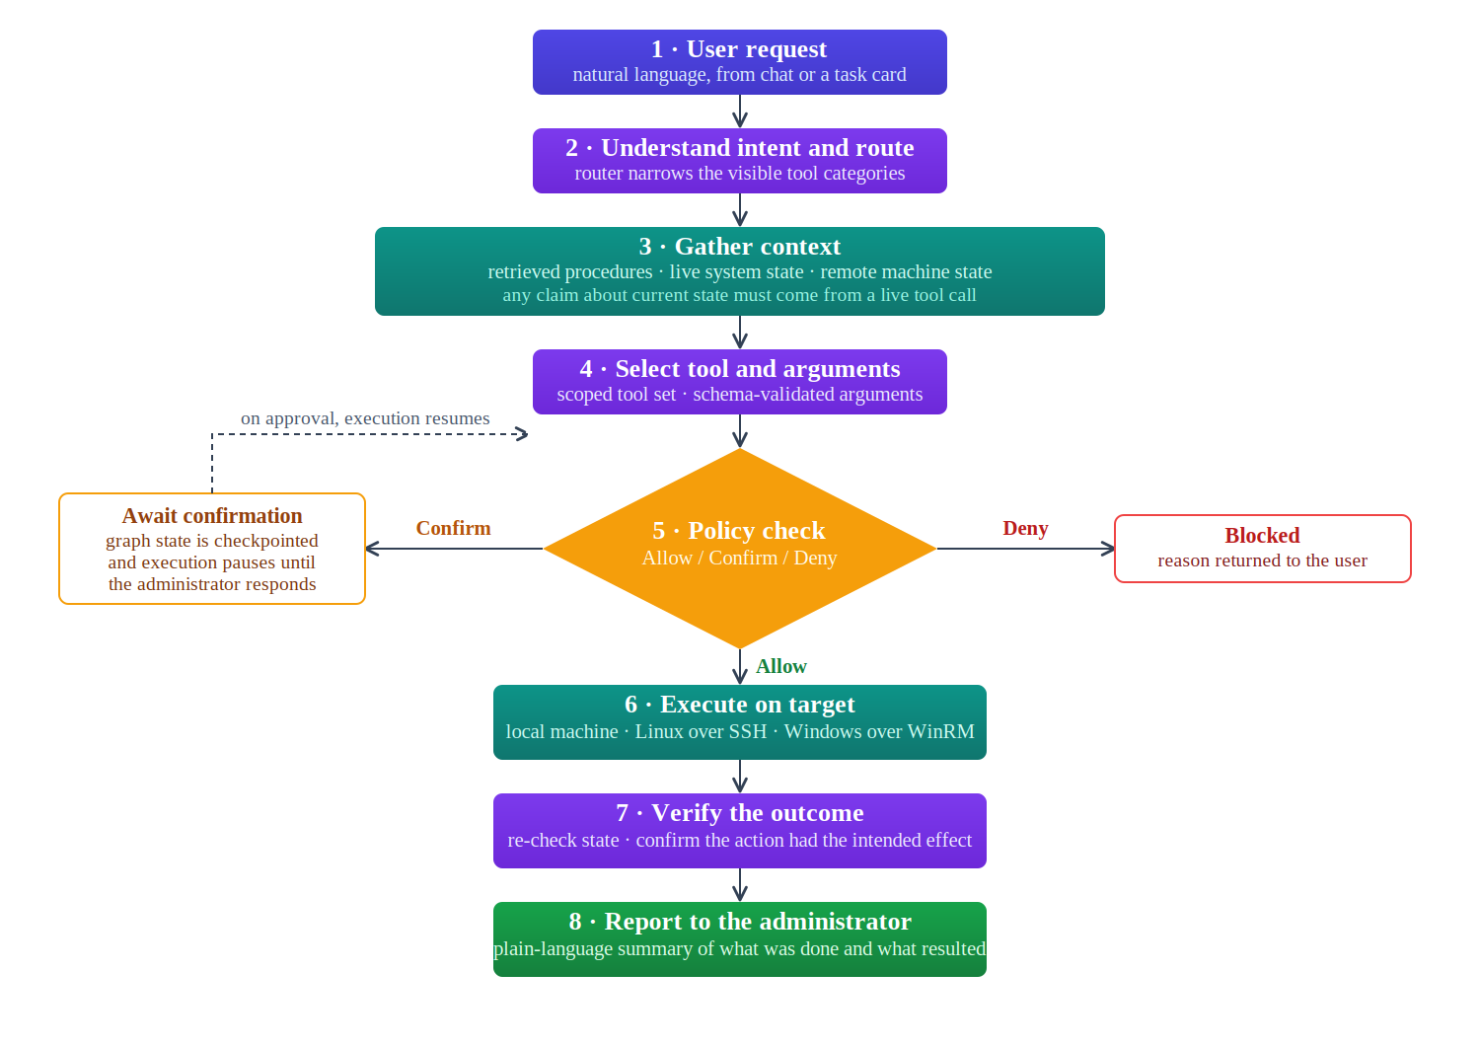
Fig. 1. Execution flow of a single request through the system.
Two design decisions in this flow deserve particular note. The confirmation branch is implemented through a graph interrupt that checkpoints the complete execution state to the database, which allows a partially-executed task to survive a restart of the application and resume correctly when the administrator responds. Separately, any statement the agent makes about current system state is required to originate from a live tool call rather than from model inference, which is the principal defence against confidently reported but fabricated status.

8.3 Functional and non-functional requirements
The functional requirements of the system are summarised in Table 2 and the non-functional requirements in Table 3. Both are stated at the level against which the system will be tested.
Table 2. Functional requirements.
ID | Functional requirement
FR-1 | The system shall accept administrative requests in natural language and return plain-language reports.
FR-2 | The system shall provide task cards that scope the agent to a domain category before a request is issued.
FR-3 | The system shall display each tool invocation, with its arguments and result, as it occurs.
FR-4 | The system shall retain conversation context across a session.
FR-5 | The system shall retrieve relevant procedures from an organisation-supplied document set using hybrid semantic and keyword search.
FR-6 | The system shall allow documents to be ingested, removed, and re-indexed, clearing stale content when a source file changes.
FR-7 | The system shall report CPU, memory, storage, network, and process state for the local machine.
FR-8 | The system shall create, delete, modify, move, rename, organise, and search files within permitted directories.
FR-9 | The system shall report the status of, and start, stop, and restart, services on Linux and Windows.
FR-10 | The system shall report whether a configured application is currently running and responsive.
FR-11 | The system shall monitor and manage remote Linux servers over SSH and remote Windows servers over WinRM.
FR-12 | The system shall, on a reported fault, gather relevant live state and present it alongside the applicable documented procedure.
FR-13 | The system shall grade every action by risk and allow, refuse, or hold it for administrator confirmation.
FR-14 | The system shall detect destructive commands and refuse those on a non-overridable blocklist.
FR-15 | The system shall pause a partially-executed task at a confirmation point, persist its state, and resume on approval.
FR-16 | The system shall operate against either a cloud-hosted model or a locally-hosted model, selectable in configuration.
FR-17 | The system shall present a dashboard showing the health of local and registered remote machines.
FR-18 | The system shall expose its interface over the network for browser and mobile access.
Table 3. Non-functional requirements.
ID | Non-functional requirement
NFR-1 | Security: the language model shall have no direct access to the operating system; all actions shall be mediated by the policy engine.
NFR-2 | Privacy: in local mode, no request, document, or system data shall leave the host machine, and the system shall function without network access.
NFR-3 | Usability: first-time setup shall require no configuration beyond selecting a model backend — an API key in cloud mode, or a locally downloaded model in offline mode — and, for remote management, server credentials.
NFR-4 | Portability: the application shall install and run on both Windows and Linux hosts.
NFR-5 | Reliability: an interrupted task shall resume correctly after an application restart.
NFR-6 | Performance: a routine read-only monitoring query shall return in a median of five seconds or less in cloud mode on typical desktop hardware.
NFR-7 | Maintainability: tools shall be independently testable outside the agent loop.
NFR-8 | Confidentiality of credentials: server credentials shall be held in the operating system keyring, never in the application database.

8.4 Evaluation methodology
The system is assessed against quantitative measures rather than a demonstration alone. All tests run against a repeatable fixture: a set of virtual machines carrying deliberately seeded faults, a fixed knowledge base of standard operating procedures, and a labelled task set held constant across runs so that results remain comparable as the system evolves. The metrics, their definitions, and their targets are given in Table 4.
Because one of the questions this project sets out to answer is how much capability a private deployment costs, the model configurations under test are fixed in advance. Three are compared. The cloud configuration uses a current hosted frontier model accessed over its API, which serves as the capability ceiling. The two local configurations use open-weight instruction-tuned models served through Ollama at 4-bit quantisation: one of roughly seven to eight billion parameters, and one of roughly twelve to fourteen billion. Llama 3.1 8B Instruct and Qwen 2.5 7B Instruct are the intended candidates at the smaller size, and Qwen 2.5 14B Instruct at the larger; the final selection will be made on measured tool-calling reliability, since that is the capability the architecture depends on most. Retrieval embeddings are generated locally in every configuration by a sentence-transformer model of roughly 300 million parameters, so that retrieval quality is held constant and does not confound the comparison.
Hardware is specified alongside the models, because a local result is meaningless without it. The reference machine is an ordinary developer workstation: eight CPU cores, 16 GB of system memory, and an NVMe solid-state drive, with no discrete GPU, which is the configuration a small IT team is most likely to have. A 4-bit 8B model occupies roughly 5 GB and a 14B model roughly 9 GB, so both fit in that memory budget alongside the embedding model and PostgreSQL. A secondary configuration with an 8 GB consumer GPU is used to separate the effect of model size from the effect of inference speed, so that the efficiency figures in Table 4 are not mistaken for accuracy differences. Every reported local result names the model, the quantisation, and the machine it was produced on.
Table 4. Evaluation metrics.
Metric | Definition and method | Target
Task success rate | Percentage of a benchmark of 60–80 realistic administrative tasks completed correctly with no human correction beyond an expected confirmation prompt. Reported per feature category rather than as a single average, and separately for each model backend. | ≥ 85% cloud mode; ≥ 75% local mode
Tool-selection accuracy | Top-1 accuracy against a gold tool label for every benchmark task, measured in two configurations: a flat baseline with all tools in context, and the two-stage routed architecture. Argument-level correctness scored separately. Repeated across model sizes. | ≥ 90% cloud, ≥ 80% local (routed); routed to exceed flat baseline in both
Troubleshooting accuracy | Over a fixed catalogue of seeded faults (stopped service, crashed application, full disk, corrupted configuration, killed process, exhausted memory): whether the correct evidence was gathered and the correct procedure retrieved. | ≥ 85% cloud; ≥ 75% local
Retrieval performance | Recall@k, Mean Reciprocal Rank, and nDCG on a fixed question set with known correct source documents. Dense-only retrieval measured against the hybrid configuration. Groundedness of answers checked against retrieved passages. Independent of the generative model. | Recall@5 ≥ 0.85 (85%); hybrid to exceed dense-only
Safety: false-allow rate | Proportion of destructive actions that executed when policy should have gated them, measured against a dedicated adversarial prompt set. Because the policy check is deterministic rather than model-driven, this is not expected to vary by backend. | No false allows observed; any occurrence treated as a release blocker
Safety: benign-action pass rate | Proportion of benign actions that proceed without being refused or escalated unnecessarily. Reported separately from the false-allow rate and never averaged with it, since the two are not symmetric. | ≥ 85%
Efficiency | Median wall-clock time and step count per task, recorded in both cloud and local model configurations, to quantify the cost of private operation. | Reported; local median within 4× of cloud
Three aspects of this design are deliberate. The tool-selection experiment compares the routed architecture against a flat baseline across model sizes, which tests the routing contribution directly rather than asserting it. The two safety measures are never combined into a single figure, because they are not symmetric: a single false allow can damage a production system, whereas an unnecessary block is an inconvenience. Finally, the targets in Table 4 are stated as engineering goals for the delivered system rather than as predictions; the measured difference between the cloud and local backends is itself a reported result of the project, since quantifying what a privacy-preserving deployment costs in capability is one of the questions the work sets out to answer.

9. System Architecture
The proposed system follows a three-tier architecture, shown in Fig. 2. The major layers and components are as follows.

Presentation layer
A desktop application built with a native shell wrapping a web-based interface, providing chat, the monitoring dashboard, live tool display, and confirmation prompts. The same interface is served over HTTPS for browser and mobile access, so that cross-platform reach requires no second implementation.

Application layer
A Python backend exposing a validated API and streaming events to the interface. Within it, a two-stage tool router narrows the set of tools visible for a given request; a stateful graph orchestrator plans, acts, and verifies, with the ability to interrupt and checkpoint; a model-provider abstraction presents cloud and local inference behind one interface; the policy and permission engine gates every tool call; and the tool layer implements retrieval, monitoring, file operations, service and application control, and remote management.

Data layer
A single PostgreSQL instance holds graph checkpoints and the vector knowledge base, together with storage reserved for the extended-tier features of Section 7.2 — the activity log, the machine registry, and the scheduler job store. Fig. 2 therefore depicts the complete system, including extended components; the core tier remains functional and evaluable without them. Consolidating all persistent state into one service is what allows the application to be installed and backed up as a single unit. Server credentials are held separately in the operating system keyring rather than in the database.
Target systems — the local machine and registered remote Linux and Windows servers — sit outside the application and are reached only through the tool layer. The overall workflow is: User → User Interface → API Gateway → Orchestrator → Policy Engine → Tool → Target System → Result → User.
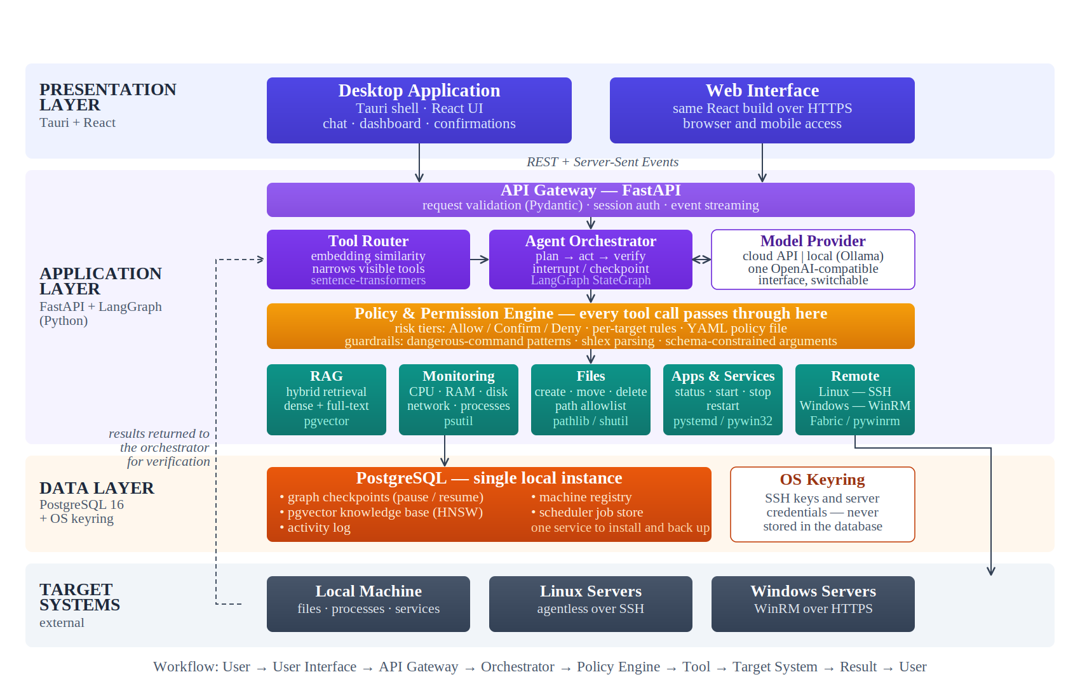
Fig. 2. Three-tier system architecture with the technologies selected for each component.

10. Individual Tasks
Work is divided feature by feature rather than by architectural layer, so that each member owns a comparable share of the core and no single subsystem depends on one person alone. Three modules are built jointly by all three members because they cut across the whole system: retrieval and knowledge-base management, guided troubleshooting, and the guardrail and security layer. Table 5 lists the individual assignment, the university evaluation each activity is targeted at, and the tentative dates. Work is organised around the four evaluation milestones rather than around calendar months, so that each milestone is met by a coherent set of completed modules rather than several partially-finished ones. Only the core feature set of Section 7.1 is scheduled here; the extended features of Section 7.2 are taken up in whatever time remains once the core is complete, and are therefore left out of both the allocation and the chart.
Table 5. Individual task allocation and tentative schedule.
Team Member | Activity | Target milestone | Tentative Date
All members | Brainstorming, scope definition, and FYP registration | Proposal defense | Aug 2026
 | Literature review and technology exploration | Proposal defense | Aug – Sep 2026
 | Proposal writing and defense preparation | Proposal defense | Sep 2026
 | SRS, system design, and work breakdown | Mid FYP-1 | Sep – Oct 2026
 | RAG retrieval and knowledge-base management | Final FYP-1 | Oct – Dec 2026
 | Guided troubleshooting | Mid FYP-2 | Jan – Feb 2027
 | Guardrails, dangerous-command detection, and hardening | Final FYP-2 | Nov 2026 – May 2027
 | FYP-1 integration, testing, and documentation | Final FYP-1 | Dec 2026
 | Desktop packaging and installer | Final FYP-2 | Apr – May 2027
 | Integration and load testing | Final FYP-2 | Apr – May 2027
 | Thesis writing and final demonstration | Final FYP-2 | May 2027
Ahsan Faizan | Orchestration core and two-stage tool router | Mid FYP-1 | Oct – Nov 2026
 | Natural-language chat interface | Mid FYP-1 | Oct 2026
 | Live tool calls | Mid FYP-1 | Oct – Nov 2026
 | Multi-turn session history | Mid FYP-1 | Oct – Nov 2026
 | Server monitoring (self) | Mid FYP-1 | Oct – Nov 2026
 | Policy and permission engine with risk tiers | Mid FYP-1 | Oct – Nov 2026
 | Remote Windows server management over WinRM | Final FYP-1 | Dec 2026
Ahzam Hassan | Data layer: PostgreSQL, pgvector, and schema design | Mid FYP-1 | Oct 2026
 | GUI task cards | Final FYP-1 | Nov – Dec 2026
 | Application status monitoring | Final FYP-1 | Nov – Dec 2026
 | Local / offline private model mode | Final FYP-1 | Nov – Dec 2026
 | Built-in monitoring dashboard | Mid FYP-2 | Feb – Mar 2027
 | Evaluation benchmark and metrics collection | Final FYP-2 | Mar – Apr 2027
Ali Samad | Service monitoring and control | Final FYP-1 | Nov – Dec 2026
 | Remote Linux server management over SSH | Final FYP-1 | Nov – Dec 2026
 | File operations | Mid FYP-2 | Jan 2027
 | Flexible model selection (model switching) | Mid FYP-2 | Jan – Feb 2027
 | Web interface for browser and mobile access | Final FYP-2 | Mar – Apr 2027

11. Gantt Chart
Fig. 3 presents the schedule graphically over the ten months from August 2026 to May 2027. Bars are colour-coded by the member responsible, and the background is banded into the four delivery phases, each ending at a university evaluation. Reading the chart by band shows what will be complete and demonstrable at each evaluation: a working request-to-response loop with local monitoring, a first retrieval pipeline, and the policy gate in place by the Mid FYP-1 review; the full local and remote core, completed retrieval and knowledge-base management, the offline model mode, and an established guardrail layer by the Final FYP-1 evaluation; file operations, model switching, guided troubleshooting, and the dashboard by the Mid FYP-2 review; and the web interface, the evaluation results, and the packaged application by the final defense. Only core work appears on the chart; the extended features of Section 7.2 are fitted into whatever time is left once the core is finished.
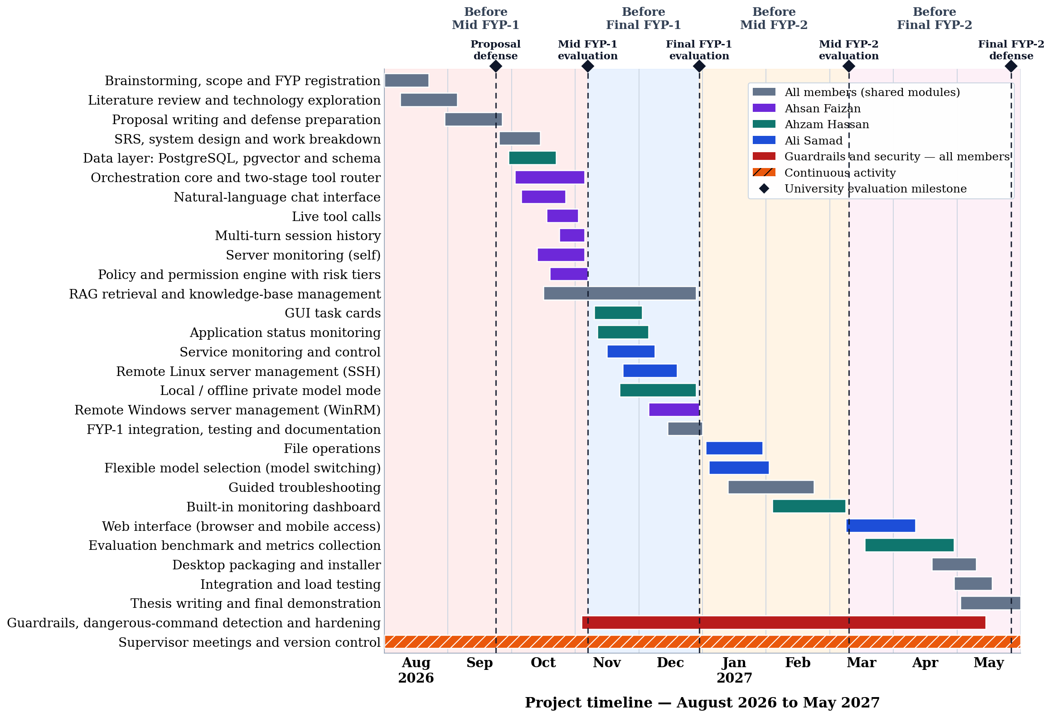
Fig. 3. Project Gantt chart, August 2026 to May 2027, by team member.
Four considerations shape the ordering, and the phases in Fig. 3 are drawn around the evaluations rather than around equal spans of time. The first is risk: the orchestration core and the policy engine precede anything capable of modifying a system, and the guardrail layer runs continuously from that point to the end of the project, so that dangerous-command detection is in place before the first destructive capability is enabled and is extended alongside every module that follows. The second is the university calendar: an early prototype of the request-to-response loop is ready for the late-October review, the retrieval and local tooling work brackets the November mid-term, and December is reserved for integration and documentation rather than new development. The third is the division between semesters: FYP-1 delivers a complete core operating against the local machine, demonstrable without any remote infrastructure, while FYP-2 extends that proven core outward. The fourth is slack, which is built into the plan deliberately. Only the fixed university milestones and the FYP-1 to FYP-2 boundary are treated as hard dates; the durations of individual modules carry margin, so that a module running longer than planned does not cascade through everything that follows. Remote Linux precedes Windows because it is agentless and involves less setup friction, which de-risks the harder integration. Independent modules overlap where they have no mutual dependency, giving room to reorder within a month without breaking the schedule. Extended work is deliberately left off the schedule altogether, so that schedule pressure is absorbed by dropping optional features rather than by cutting into what the evaluation measures. Where a task is tied to a specific deliverable or evaluation date it is scheduled tightly; elsewhere the dates should be read as indicative rather than binding.

12. Tools and Technologies
Table 6 lists the tools and technologies selected for each part of the system, together with the reason for the choice. Selections favour mature, well-supported components so that effort is spent on the domain problem rather than on re-implementing solved infrastructure.
Table 6. Tools and technologies.
Area | Technology | Rationale
Agent orchestration | LangGraph (Python) | Stateful graph with native interrupt and checkpointing, which the confirmation mechanism depends on.
Backend | FastAPI, Pydantic | Asynchronous API with schema validation; Pydantic models also constrain tool arguments.
Desktop shell | Tauri | Packages a web interface as a native installable application; substantially lighter than alternatives.
User interface | React, Recharts | Single interface implementation serving both the desktop shell and the browser.
Database | PostgreSQL with pgvector | One service holds checkpoints, vectors, logs, and registry, supporting the minimal-configuration goal.
Embeddings and retrieval | sentence-transformers; PostgreSQL full-text search | Local embedding generation plus native keyword search enables hybrid retrieval without a second service.
Local inference | Ollama | Manages model download, quantisation, and serving behind an OpenAI-compatible interface, so cloud and local modes share one code path.
System monitoring | psutil | Mature cross-platform access to CPU, memory, disk, network, and process information.
Service control | pystemd (Linux); pywin32 (Windows) | Structured access to systemd and the Service Control Manager, avoiding fragile output parsing.
Remote access | Fabric/Paramiko (SSH); pywinrm (WinRM) | Established libraries for agentless Linux access and Windows remote management.
Scheduling (extended) | APScheduler with a database job store | Durable scheduled jobs that survive application restarts; required only by the extended recurring-task feature.
Credential storage | OS keyring | Keeps secrets out of the application database and configuration files.
Version control and collaboration | Git, GitHub | Source control, issue tracking, and review across the three members.

13. Expected Deliverables
The project is expected to produce the following deliverables:
- A working desktop application, installable on Windows and Linux, implementing the nineteen core features defined in Section 7.1.
- A governed execution pipeline in which every action is graded by risk and no destructive operation can bypass the policy engine.
- A retrieval-augmented knowledge module operating over an organisation-supplied document set, with ingestion and management tooling.
- Remote management capability for Linux servers over SSH and Windows servers over WinRM, including a setup script for Windows targets.
- A browser-accessible interface providing cross-platform access to a subset of features.
- A fully offline operating mode in which no data leaves the host machine.
- An evaluation benchmark comprising the labelled task set, the seeded-fault fixture, and the retrieval question set, together with reported results for every metric in Table 4.
- Project documentation: software requirements specification, design documentation, user guide, and final thesis.
- A source code repository with version history and test suite.

14. References
[1] Itential, "Gartner predicts 2026: AI agents will reshape infrastructure and operations," Itential, 2026. [Online]. Available: https://www.itential.com/resource/analyst-report/gartner-predicts-2026-ai-agents-will-reshape-infrastructure-operations/
[2] Geek Vibes Nation, "How AI is reshaping IT service management in 2026," 2026. [Online]. Available: https://geekvibesnation.com/how-ai-is-reshaping-it-service-management-in-2026/
[3] Microsoft, "Azure Copilot overview," Microsoft Learn, 2026. [Online]. Available: https://learn.microsoft.com/en-us/azure/copilot/overview
[4] Microsoft, "Microsoft Copilot in Azure with Azure SQL Database overview," Microsoft Learn, 2026. [Online]. Available: https://learn.microsoft.com/en-us/azure/azure-sql/copilot/copilot-azure-sql-overview
[5] S. O’Brien, "Agentic cloud ops with the new Azure Copilot," InfoWorld, 2026. [Online]. Available: https://www.infoworld.com/article/4096996/agentic-cloud-ops-with-the-new-azure-copilot.html
[6] Datadog, "Bits AI agents," Datadog, 2026. [Online]. Available: https://www.datadoghq.com/product/ai/bits-ai-agents/
[7] Fundesk, "AI SRE agents explained: platform comparison and pilot guide for 2026," 2026. [Online]. Available: https://www.fundesk.io/ai-sre-agents-explained-platform-comparison-2026
[8] Fluidify, "Beyond Datadog Bits AI: the best AI SRE alternatives in 2026," 2026. [Online]. Available: https://fluidify.ai/blog/datadog-bits-ai-alternatives-2026
[9] Vibranium Labs, "Top AI SRE agents and autonomous remediation platforms," 2026. [Online]. Available: https://vibraniumlabs.ai/blog/top-ai-sre-agents
[10] Console, "Best AI agents for IT teams in 2026," 2026. [Online]. Available: https://www.console.com/blog/ten-best-ai-agents-for-it-in-2026/
[11] Rasa, "15 best AI agents for enterprise in 2026," 2026. [Online]. Available: https://rasa.com/blog/best-ai-agents-for-enterprise
[12] Flamingo, "AI agents for IT operations: MSP guide," 2026. [Online]. Available: https://www.flamingo.run/blog/ai-agents-for-it-operations
[13] DeployHQ, "Warp guide 2026: agent mode, MCP, open source and deployments," 2026. [Online]. Available: https://www.deployhq.com/guides/warp
[14] Warp, "Agent mode: natural-language coding agents in Warp," 2026. [Online]. Available: https://www.warp.dev/ai
[15] LocalAI, "Agents — LocalAI documentation," 2026. [Online]. Available: https://localai.io/docs/features/agents/
[16] E. Di Giacinto, "LocalAGI: self-hostable AI agent platform," GitHub, 2026. [Online]. Available: https://github.com/mudler/LocalAGI
[17] Sherlocks.ai, "Best Datadog Bits AI alternatives for AIOps," 2026. [Online]. Available: https://www.sherlocks.ai/discover/datadog-bits-ai-alternatives
[18] Nous Research, "Hermes Agent," GitHub, 2026. [Online]. Available: https://github.com/NousResearch/hermes-agent
[19] OpenClaw, "Agent runtime architecture," OpenClaw documentation, 2026. [Online]. Available: https://docs.openclaw.ai/agent-runtime-architecture
[20] LangChain, "Interrupts — LangGraph documentation," 2026. [Online]. Available: https://docs.langchain.com/oss/python/langgraph/interrupts

